Social Anxiety Disorder

**Social anxiety disorder, sometimes referred to as social phobia, is a type of anxiety disorder that causes extreme fear in social settings. People with this disorder have trouble talking to people, meeting new people, and attending social gatherings. They fear being judged or scrutinized by others. They may understand that their fears are irrational or unreasonable, but feel powerless to overcome them.**

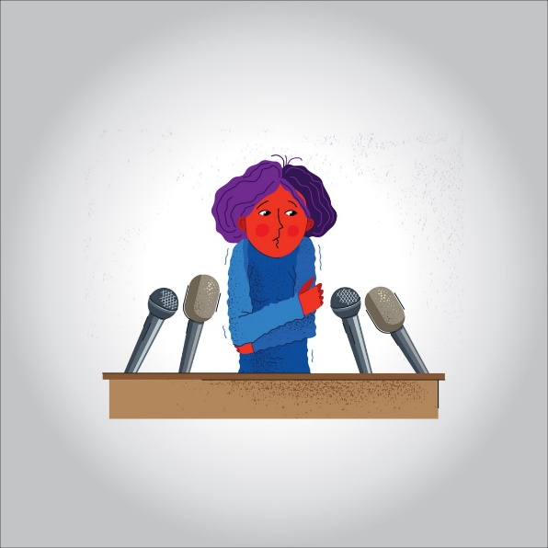

**Social anxiety is different from shyness. Shyness is usually short-term and doesn’t disrupt one’s life. Social anxiety is persistent and debilitating. It can affect one’s ability to:**

* **work**
* **attend school**
* **develop close relationships with people outside of their family**

**Symptoms of this disorder may start around the age of 13.**

**Symptoms of Social Anxiety Disorder**

**Social interaction may cause the following physical symptoms:**

* **blushing**
* **nausea**
* **excessive sweating**
* **trembling or shaking**
* **difficulty speaking**
* **dizziness or lightheadedness**
* **rapid heart rate**

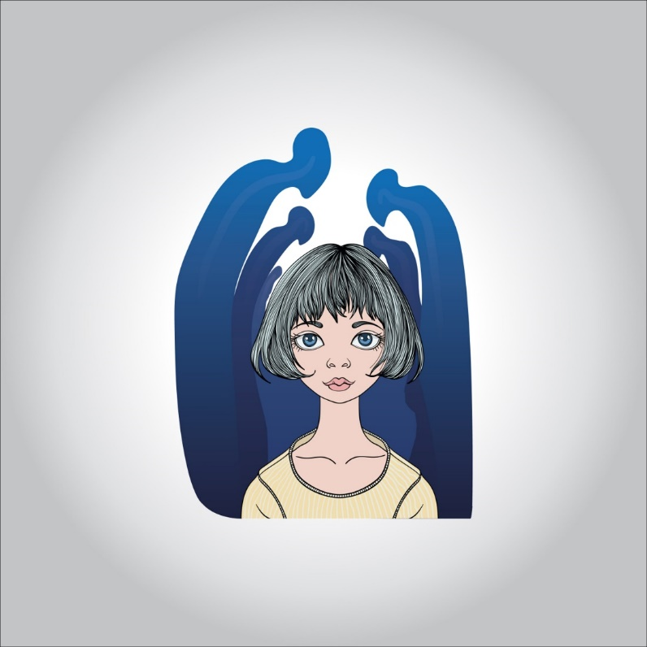

**Psychological symptoms may include:**

* **worrying intensely about social situations**
* **worrying for days or weeks before an event**
* **avoiding social situations or trying to blend into the background if you must attend**
* **worrying about embarrassing yourself in a social situation**
* **worrying that other people will notice you are stressed or nervous**
* **needing alcohol to face a social situation**
* **missing school or work because of anxiety**

**It is normal to sometimes feel anxious. However, when you have social phobia, you have a constant fear of being judged by others or humiliated in front of them. You may avoid all social situations, including:**

* **asking a question**
* **job interviews**
* **shopping**
* **using public restrooms**
* **talking on the phone**
* **eating in public**

**Symptoms of social anxiety may not occur in all situations. You can have limited or selective anxiety. For example, symptoms may only occur when you’re eating in front of people or talking to strangers. Symptoms can occur in all social settings if you have an extreme case.**

**What Causes Social Anxiety Disorder?**

**The exact cause of social phobia is unknown. However, current research supports the idea that it is caused by a combination of environmental factors and genetics. Negative experiences also may contribute to this disorder, including:**

* **bullying**
* **family conflict**
* **sexual abuse**

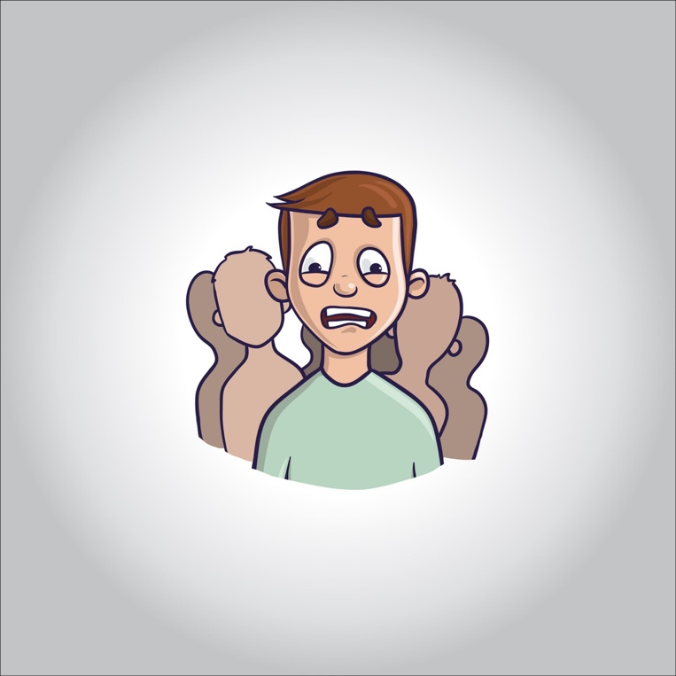

**Physical abnormalities such as a serotonin imbalance may contribute to this condition. Serotonin is a chemical in the brain that helps regulate mood. An overactive amygdala (a structure in the brain that controls fear response and feelings or thoughts of anxiety) may also cause these disorders.**

**Anxiety disorders can run in families. However, researchers aren’t sure if they’re actually linked to genetic factors. For example, a child might develop an anxiety disorder by learning the behavior of one of their parents who has an anxiety disorder. Children can also develop anxiety disorders as a result of being raised in controlling or overprotective environments.**

**Diagnosing Social Anxiety Disorder**

**There is no medical test to check for social anxiety disorder. Your healthcare provider will diagnose social phobia from a description of your symptoms. They can also diagnose social phobia after examining certain behavioral patterns.**

**During your appointment, your healthcare provider will ask you to explain your symptoms. They will also ask you to talk about situations that cause your symptoms. The criteria for social anxiety disorder include:**

* **a constant fear of social situations due to fear of humiliation or embarrassment**
* **feeling anxious or panicky before a social interaction**
* **a realization that your fears are unreasonable**
* **anxiety that disrupts daily living**

**Treatment for Social Anxiety Disorder**

**Several types of treatment are available for social anxiety disorder. Treatment results differ from person to person. Some people only need one type of treatment. However, others may require more than one. Your healthcare provider may refer you to a mental health provider for treatment. Sometimes, primary care providers may suggest medication to treat symptoms.**

**Treatment options for social anxiety disorder include:**

**Cognitive behavioral therapy**

**This therapy helps you learn how to control anxiety through relaxation and breathing, and how to replace negative thoughts with positive ones.**

**Exposure therapy**

**This type of therapy helps you gradually face social situations, rather than avoiding them.**

**Group therapy**

**This therapy helps you learn social skills and techniques to interact with people in social settings. Participating in group therapy with others who have the same fears may make you feel less alone. It will give you a chance to practice your new skills through role-playing.**

**At-home treatments include:**

**Avoiding caffeine**

**Foods such as coffee, chocolate, and soda are stimulants and may increase anxiety.**

**Getting plenty of sleep**

**Getting at least eight hours of sleep per night is recommended. Lack of sleep can increase anxiety and worsen symptoms of social phobia.**

**Your healthcare provider may prescribe medications that treat anxiety and depression if your condition doesn’t improve with therapy and lifestyle changes. These medications do not cure social anxiety disorder. However, they can improve your symptoms and help you function in your daily life. It can take up to three months for medication to improve your symptoms.**

**Medications approved by the Food and Drug Administration (FDA) to treat social anxiety disorder include Paxil, Zoloft, and Effexor XR. Your healthcare provider may start you with a low dose of medication and gradually increase your prescription to avoid side effects.**

**Common side effects of these medications include:**

* **insomnia (sleeplessness)**
* **weight gain**
* **upset stomach**
* **lack of sexual desire**

**Talk to your health care provider about the benefits and risks to decide which treatment is right for you.**

**Outlook for Social Anxiety Disorder**

**According to the ADAA, about 36 percent of people with social anxiety don’t speak to a healthcare provider until they have had symptoms for at least 10 years.**

**People with social phobia may rely on drugs and alcohol to cope with anxiety triggered by social interaction. Left untreated, social phobia can lead to other high-risk behaviors, including:**

* **alcohol and drug abuse**
* **loneliness**
* **thoughts of suicide**

**The outlook for social anxiety is good with treatment. Therapy, lifestyle changes, and medication can help many people cope with their anxiety and function in social situations.**

**Social phobia doesn’t have to control your life. Although it may take weeks or months, psychotherapy and/or medication can help you begin to feel calmer and more confident in social situations.**

**Keep your fears under control by:**

* **recognizing the triggers that cause you to start feeling nervous or out of control**
* **practicing relaxation and breathing techniques**
* **taking your medication as directed**